Day 30 27th Aug 2025

Architecture

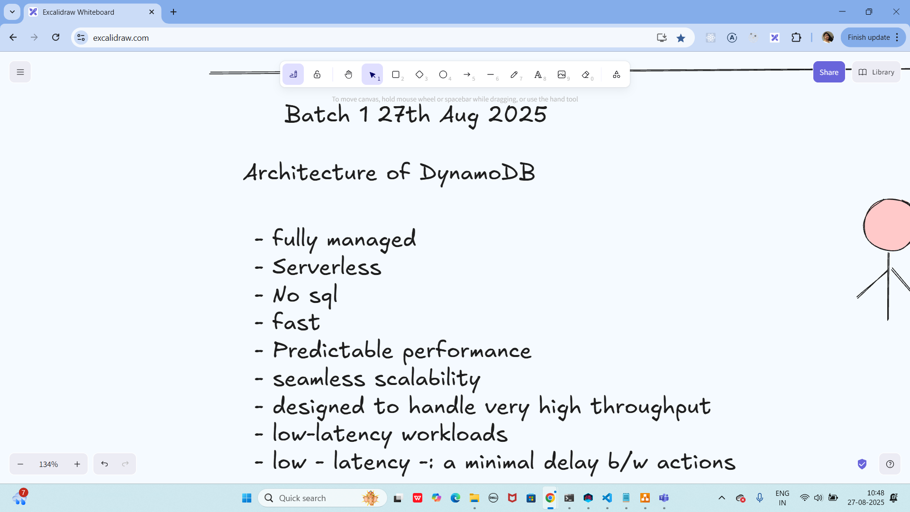

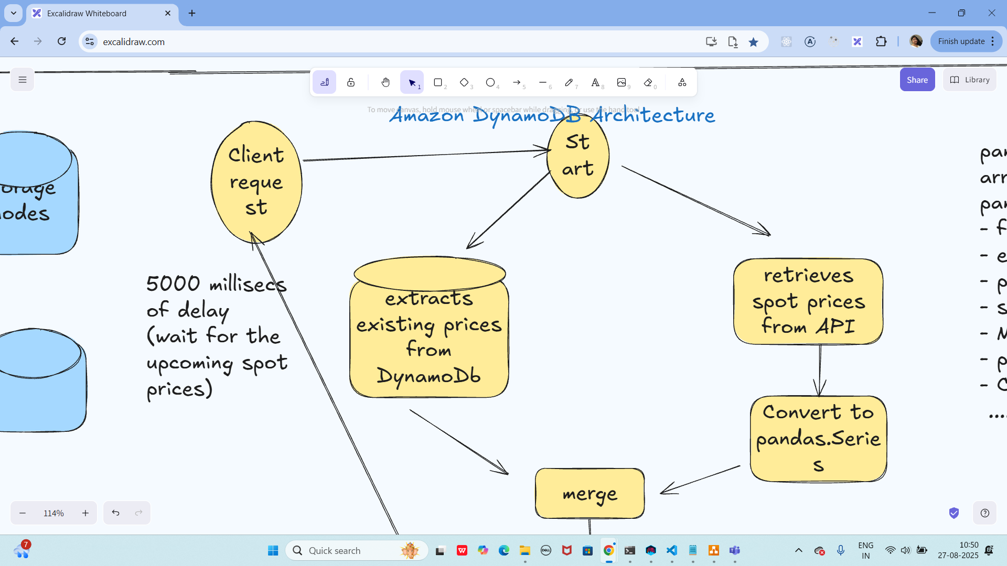

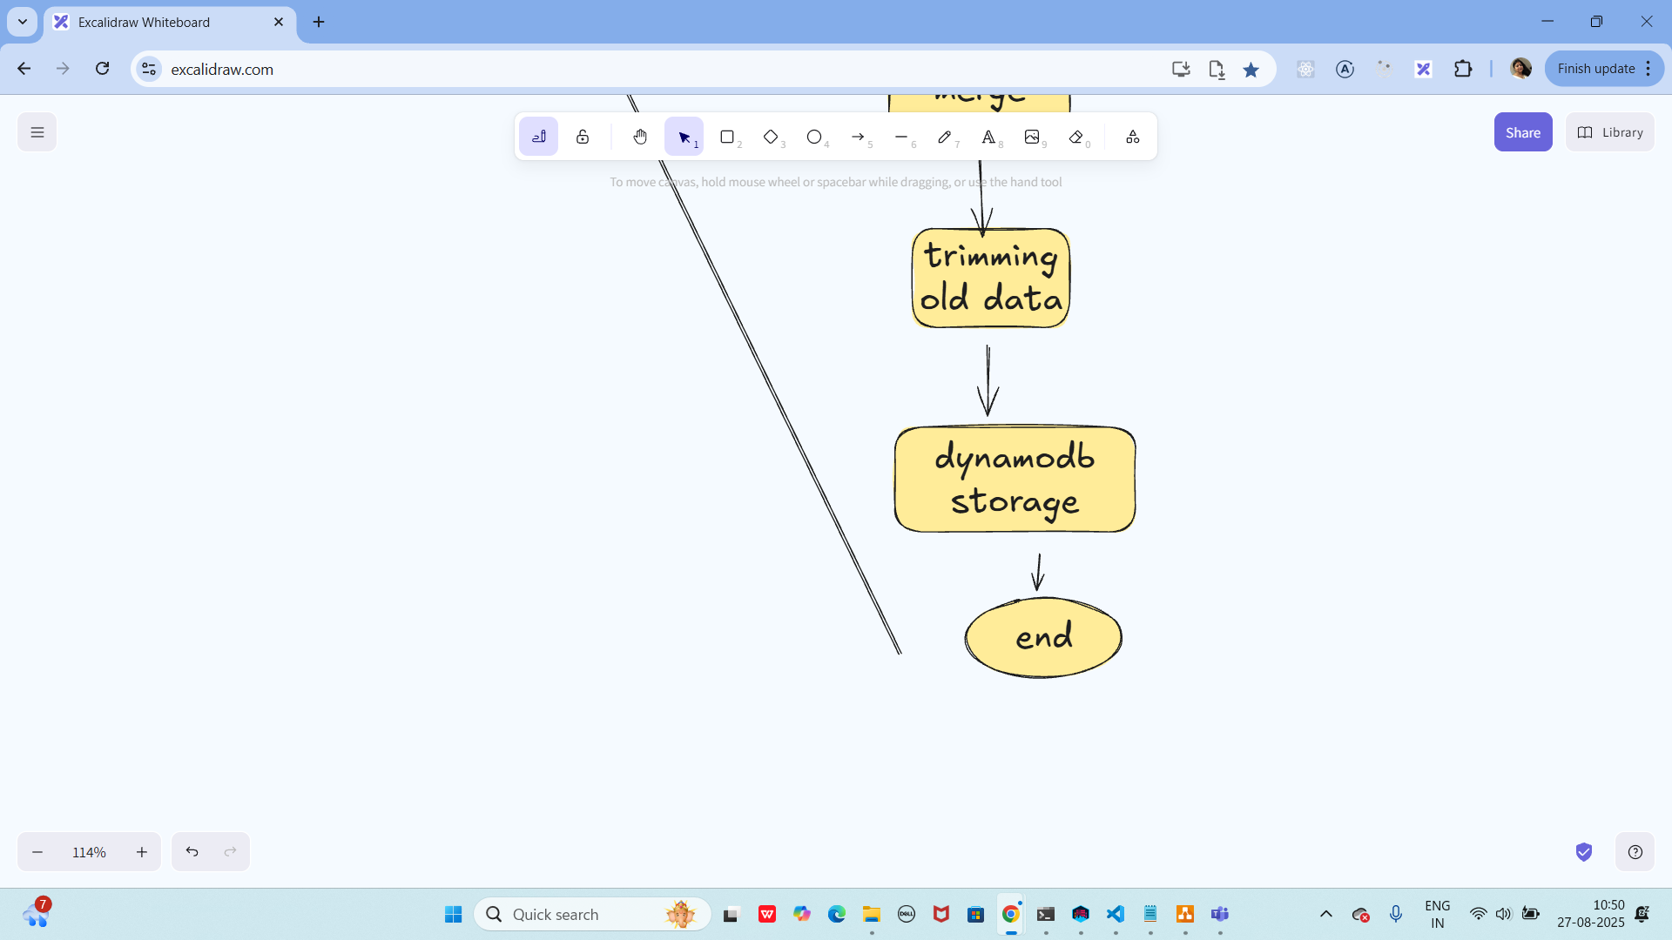

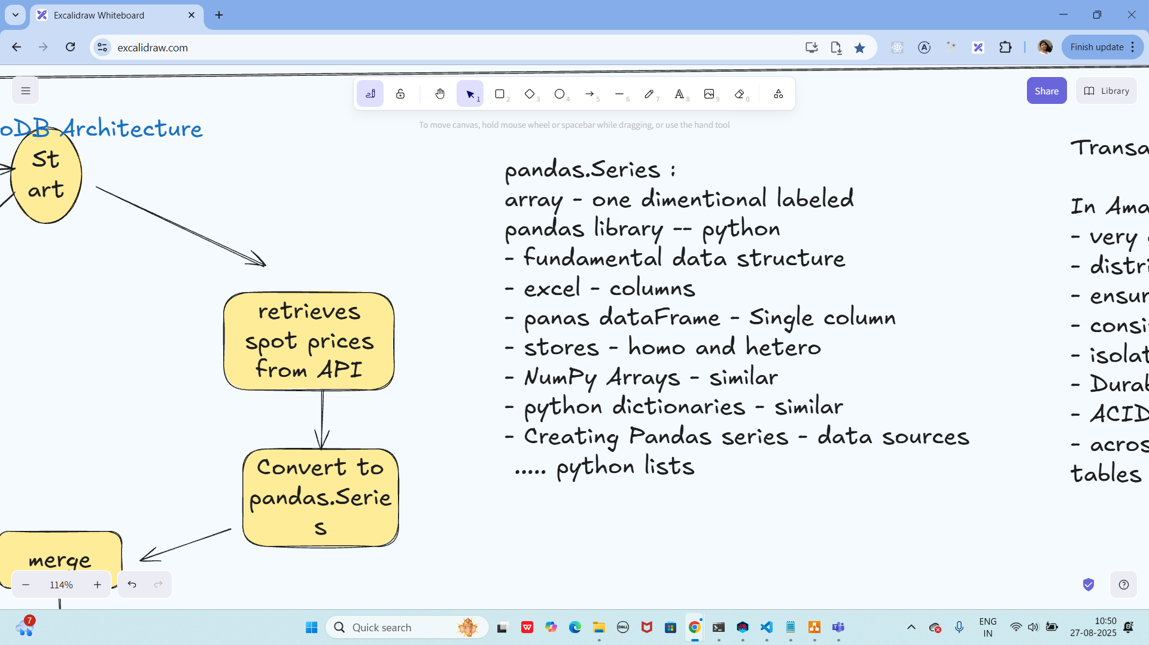

1.45 to 2.45 lunch:

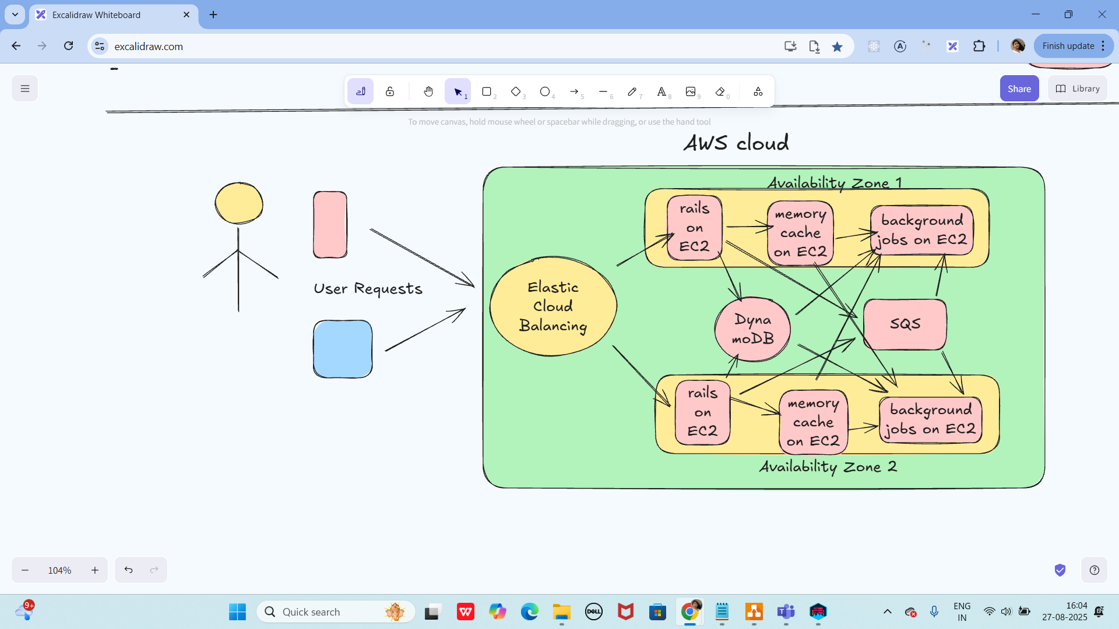

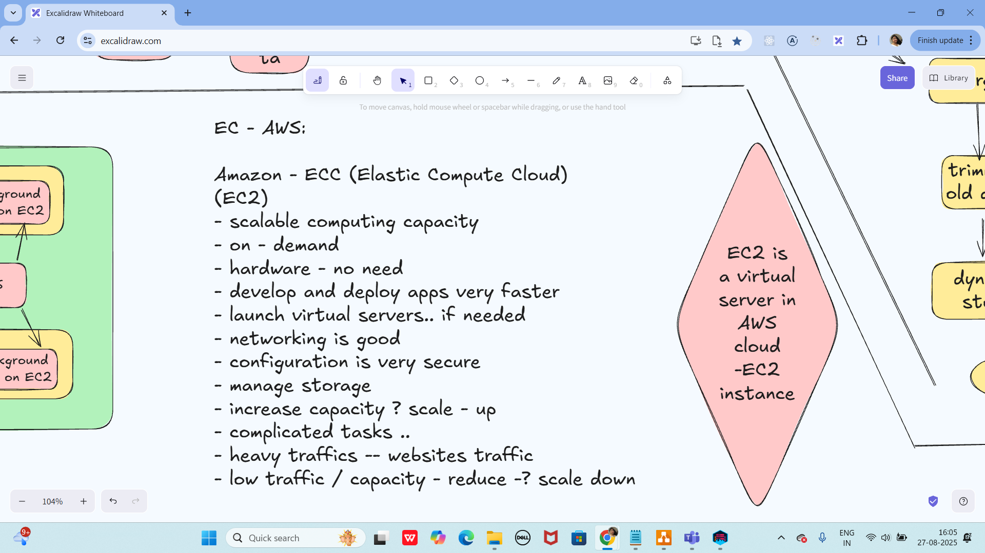

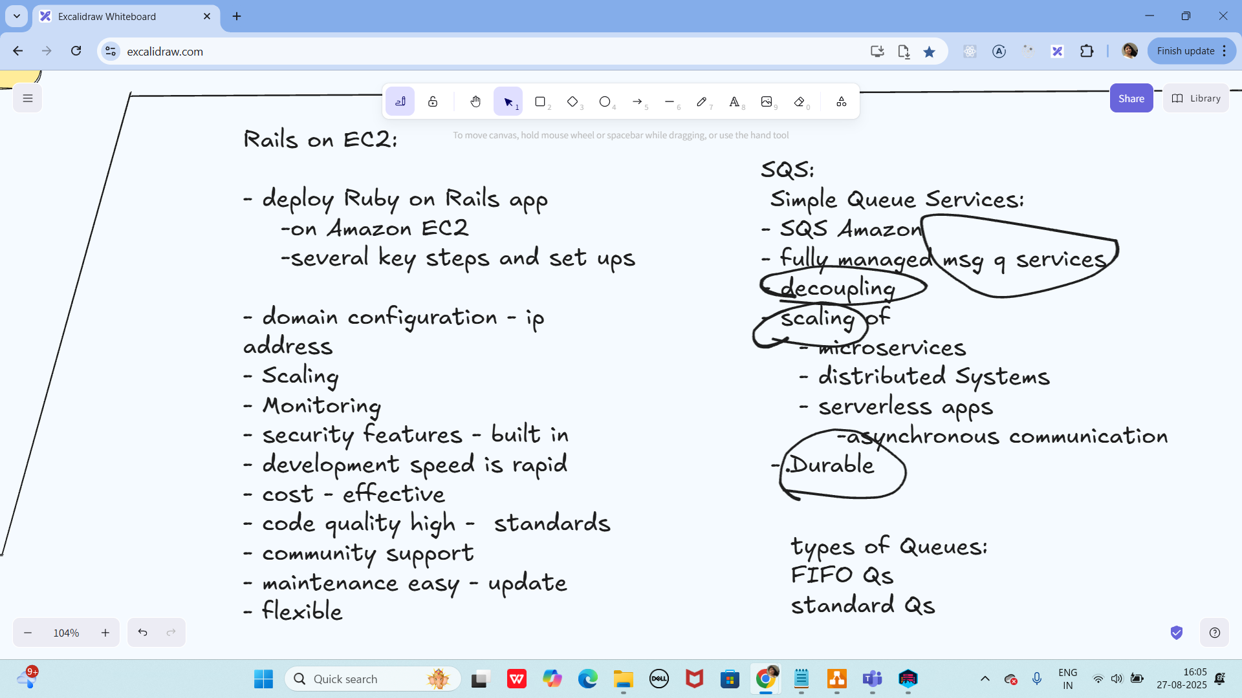

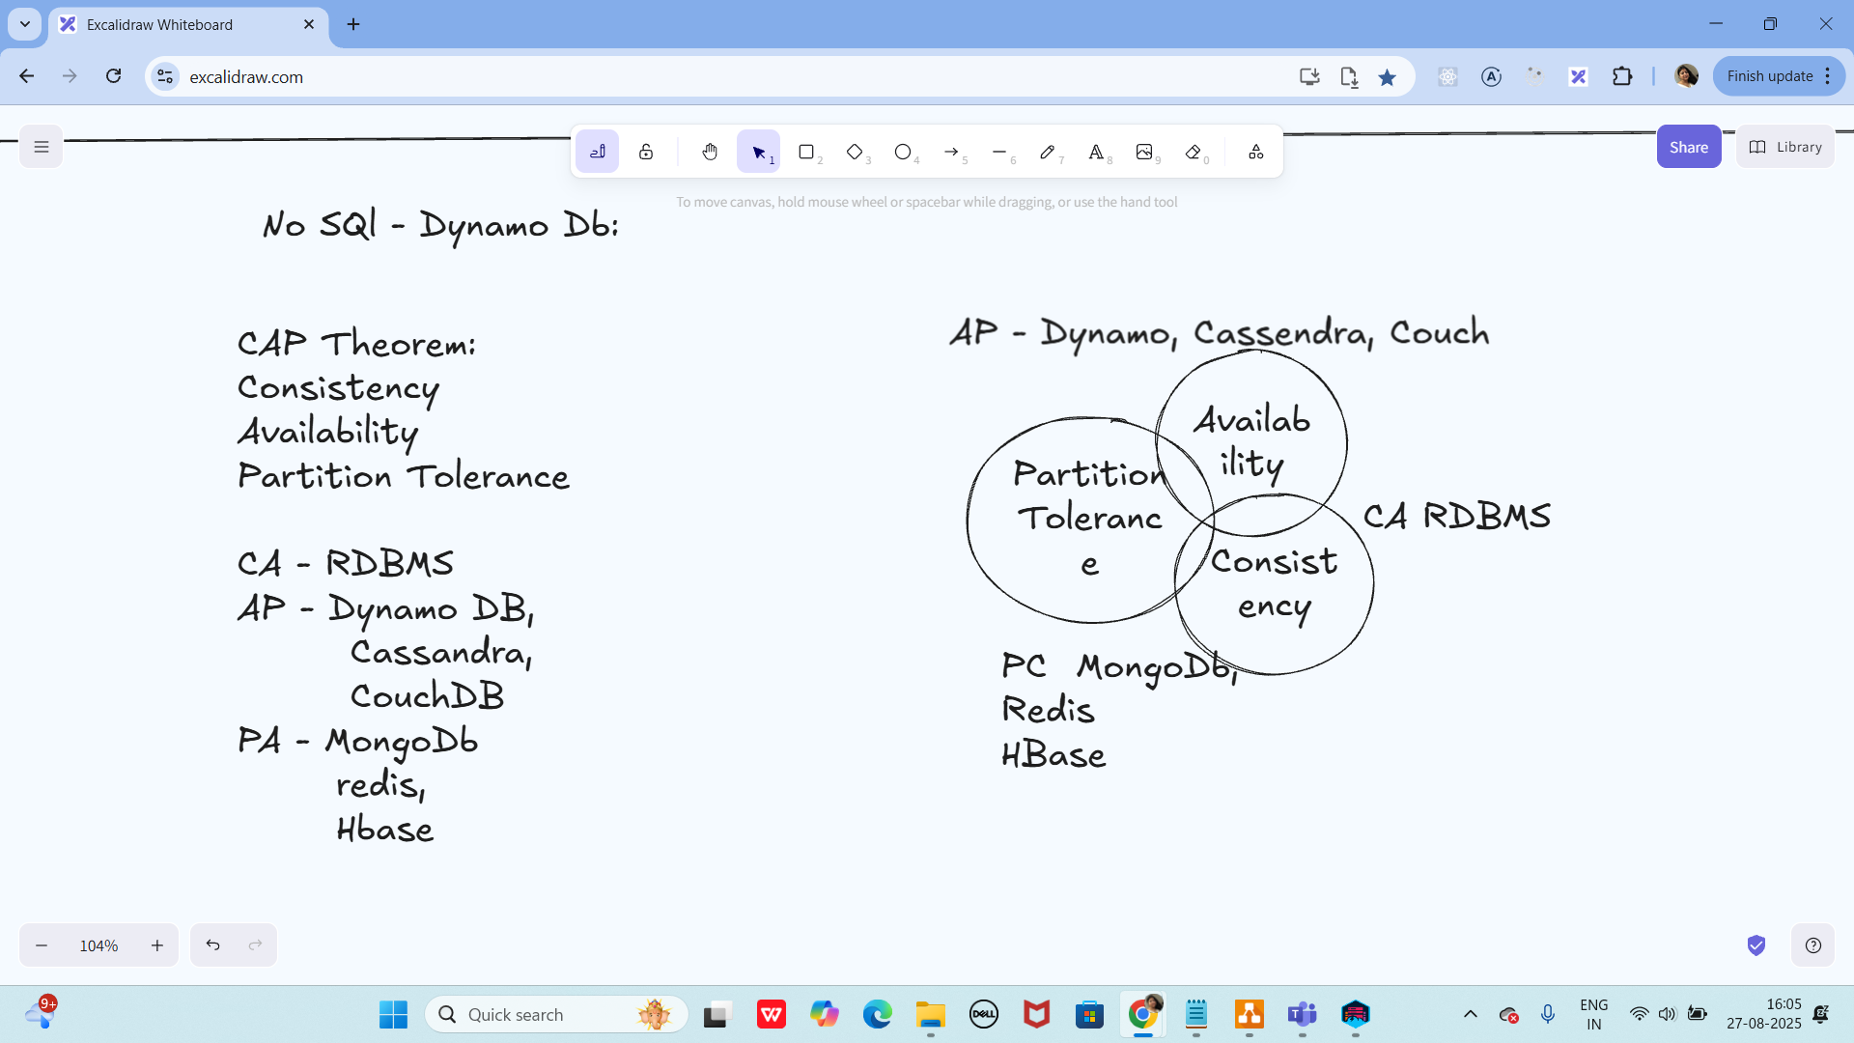

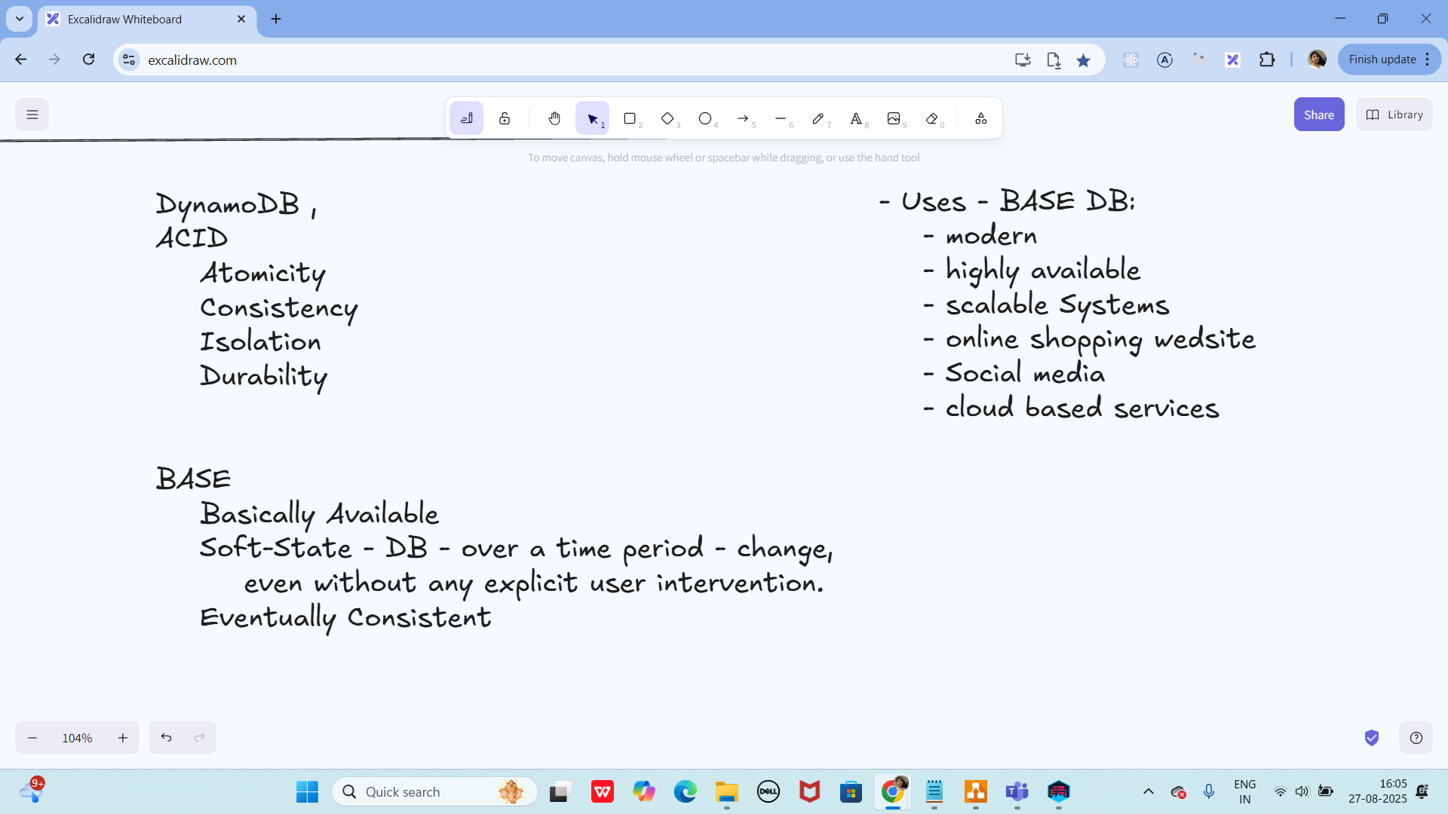

Info Box:

======================================================================

<dependencies>
<!-- AWS SDK v2 for DynamoDB -->
<dependency>
<groupId>software.amazon.awssdk</groupId>
<artifactId>dynamodb</artifactId>
<version>2.25.61</version> <!-- use latest stable -->
</dependency>

<!-- Jackson (for JSON) -->
<dependency>
<groupId>com.fasterxml.jackson.core</groupId>
<artifactId>jackson-databind</artifactId>
<version>2.17.2</version>
</dependency>
</dependencies>
<dependency>
<groupId>com.fasterxml.jackson.core</groupId>
<artifactId>jackson-databind</artifactId>
<version>2.20.0-rc1</version>
</dependency>

AwsBasicCredentials awsCreds = AwsBasicCredentials.create("dummy", "dummy");

AmazonDynamoDBClient client = new AmazonDynamoDBClient(new com.amazonaws.auth.BasicAWSCredentials("FakeaccessKey","FakeSecretKey”));

DynamoDB dynamoDB = new DynamoDB(client);

=====================================================================

Excalidraw updated at 10.47

https://excalidraw.com/#json=0zlc-Blwv_3H-UmKoVCj1,oRBmqtN2dJ7dkzJ8UAhrXA

Excalidraw updated at 16.03:

https://excalidraw.com/#json=M2ML_ruh5B3w-47K7ALKc,NXXmmkpRfZb6y-0E9-uy6A

